CS-322 Software Construction



Project Management System

PRESENTED BY
Team Leader : Fahim Mirzae
Team Member : Shahzaib Khan
Team Member : Maisam Arifi

SUPERVISED BY
Dr. Onaiza Maqbool

Department of Computer Science
Quaid-e-Azam University, Islamabad
Project Manager
______________________ _______________________
Signature Date
Fahim Mirzae
Student, QAU Islamabad
Member 1
______________________ _______________________
Signature Date
Shahzaib Khan
Student, QAU Islamabad
Member 2
______________________ _______________________
Signature Date
Maisam Arifi
Student, QAU Islamabad

Member 3
______________________ _______________________
Signature Date
Dr. Onaiza Maqbool
Professor, QAU Islamabad
Change History

Version No. | Date | Modified  By | Changes
1 | 07/10/2026 | Fahim Mirzae  Shahzaib Khan  Maisam Arifi | Original

Remarks

____________________
Signature

Dr. Onaiza Maqbool
Professor, QAU Islamabad

Introduction

This case study describes an online bakery ordering website that allows a customers to order the bakery items conveniently. The customer can view different categories and select the required items from the available list. The system calculates the order total and can apply available discounts and package deals. Customers must also select a valid delivery area before placing an order. The system accepts payment through credit card and assigns a salesman for delivery after successful payment. It also supports advance booking of orders with a specified deadline.

Scope

The Bakery online Ordering system will Cover the following parts :
- Record and manage delivery details (e.g.: delivery number , counts, order items, salesperson information , deadline ).
- Managing the bakery categories and items.
- Allowing the customer to select the items from the item list and location /area.
- Creating , managing the orders and calculating the price of customer orders.
- The system is processing the online credit card payment .
- Maintaining records of customers, orders , payments and deliveries.

- Project Name
Online Bakery Ordering System
- Main Functionality

- • View Bakery Categories and Items
The customer can view different bakery categories and see the available items with their prices.
- • Select Bakery Items
The customer can select the required bakery items and enter the quantity they want to order.
- • Calculate Order Total
The system calculates the total price of the selected items and updates the amount when the customer changes the quantity or removes an item.
- • Apply Discounts and Package Deals
The system checks whether the selected items are eligible for any discount or package deal and updates the total accordingly.
- • Select Delivery Area
The customer selects the area where the order needs to be delivered and provides the required address details.
- • Validate Delivery Area
The system checks whether the selected area is available for bakery delivery. If the area is not supported, the customer is asked to select another area.
- • Place an Order
After selecting the items and delivery area, the customer can place the order in the system.
- • Book an Order
The customer can make an order in advance for a future date or deadline.
- • Make Payment
The customer can pay for the order through the available online payment method. The system verifies and records the payment.
- • Assign Salesman
After successful payment, the system assigns a salesman to deliver the order.
- • Deliver Order
The assigned salesman receives the order details and delivers the bakery items to the customer's selected location.

- Definitions

• View Bakery Categories and Items
The customer can view different bakery categories and see the available items with their prices.
• Select Bakery Items
The customer can select the required bakery items and enter the quantity they want to order.
• Calculate Order Total
The system calculates the total price of the selected items and updates the amount when the customer changes the quantity or removes an item.
• Apply Discounts and Package Deals
The system checks whether the selected items are eligible for any discount or package deal and updates the total accordingly.
• Select Delivery Area
The customer selects the area where the order needs to be delivered and provides the required address details.
• Validate Delivery Area
The system checks whether the selected area is available for bakery delivery. If the area is not supported, the customer is asked to select another area.
• Place an Order
After selecting the items and delivery area, the customer can place the order in the system.
• Book an Order
The customer can make an order in advance for a future date or deadline.
• Make Payment
The customer can pay for the order through the available online payment method. The system verifies and records the payment.
• Assign Salesman
After successful payment, the system assigns a salesman to deliver the order.
• Deliver Order
The assigned salesman receives the order details and delivers the bakery items to the customer's selected location.
References
- IEEE Standard for Software Requirements Specifications (IEEE Std 830-1998).
- ISO/IEC/IEEE 16326:2019 Guidelines for Life Cycle Processes – Project Management.
- ISO/IEC/IEEE 16326: Systems and Software Engineering – Project Management
- Software Engineering: A Practitioner's Approach – Roger S. Pressman
- Project Management for Software Engineering – Richard H. Thayer

- Product Functions

The Online Bakery Ordering System will provide the following main product functions:
- Product and Category Display
The system will display bakery categories and the items available under each category so that customers can view and select products.
- Order Selection and Total Calculation
The system will allow customers to select items and quantities, then calculate and display the total order amount.
- Discount and Package Deal Handling
The system will check the selected items for available discounts and package deals and apply them when the required conditions are met.
- Delivery Area Management
The system will require the customer to select a delivery area and will check that the area is included in the bakery's delivery list.
- Order Booking
The system will allow customers to place normal or advance orders and store the deadline for booked orders.
- Payment Processing
The system will accept payment through credit card and confirm the order after successful payment.
- Salesman Assignment and Delivery Logging
After successful payment, the system will assign a salesman for delivery and record the relevant delivery details.

- Constraints

- • Delivery Area Constraint
The customer must select a delivery area from the list maintained by the website. Orders cannot be delivered outside the available areas.
- • Payment Constraint
The system accepts payment through credit card. An order cannot be confirmed if the payment is not completed successfully.
- • Product Availability Constraint
The customer can only select bakery items that are already available in the system. The order must be based on the existing item list.
- • Booked Order Deadline Constraint
For advance or booked orders, a specific deadline must be assigned and the order has to be processed according to that deadline.
- • Discount and Package Deal Constraint
Discounts and package deals are applied only when their required conditions are satisfied. For example, the free item offer is applied only when the specified purchase condition is met.
• Delivery Timing Constraint
The delivery depends on the specified delivery time and area, so delays may occur because of practical conditions such as traffic or weather.

Specific Requirements Functional Requirements (Use Cases)

FR-01: View Bakery Items
The system shall allow the customer to view the available bakery categories and products along with their prices.
FR-02: Select Bakery Items
The system shall allow the customer to select bakery items and enter the required quantity.

FR-03: Manage Selected Items
The system shall allow the customer to remove a selected item or change its quantity before completing the order.

FR-04: Calculate Order Total
The system shall calculate the total price of the selected items based on their quantities.
FR-05: Apply Package Deals
The system shall check whether the selected items qualify for a package deal and update the total price when applicable.
FR-06: Apply Discounts
The system shall check for valid discounts and reduce the order total when the discount condition is satisfied.
FR-07: Select Delivery Area
The system shall allow the customer to select a delivery area from the available areas.
FR-08: Enter Delivery Address
The system shall allow the customer to enter the required address details, such as house number and street.
FR-09: Validate Delivery Area
The system shall check whether the selected delivery area is supported by the bakery.
FR-10: Display Delivery Information
The system shall display the selected area, its validity status, and the applicable delivery charges.
FR-11: Place an Order
The system shall allow the customer to place the order after selecting the required items and providing valid delivery information.
FR-12: Book an Order
The system shall allow the customer to make an order in advance and store the required deadline.
FR-13: Make Payment
The system shall allow the customer to make payment for a placed order using the available payment method.
FR-14: Validate Payment Details
The system shall check the payment details entered by the customer before processing the payment.
FR-15: Handle Failed Payment
The system shall show an error message when a payment fails and allow the customer to try again.
FR-16: Generate Payment Record
The system shall save the successful payment record and generate a payment ID, payment status, and receipt number.
FR-17: Assign Salesman
The system shall assign an available salesman to the order after successful payment.
FR-18: Manage Delivery
The system shall store the delivery details and provide the assigned salesman with the required order information.
FR-19: Maintain Order Records
The system shall maintain records of customers, orders, payments, bakery items, and deliveries.

FR-20: Customer Feedback
The system shall allow the customer to provide feedback about the bakery items.
Non-Functional Requirements

The non functionals requirements are based on the project plan, including its constraints, objectives, tools, security measures, and maintenance plans.
Security
The system should protect customer, payment, and order information from unauthorized access.
The system should use safe login, encryption, and role-based access where required.
Performance
The system should respond quickly when customers select items, calculate totals, place orders, or make payments.
The main ordering functions should work without unnecessary delay.
Usability
The system should provide a simple and easy-to-understand interface for customers, bakery staff, and salesmen.
Customers should be able to select products, delivery areas, and payment options without difficulty.
Reliability
The system should maintain correct and consistent records of customers, orders, payments, and deliveries.
The system should continue working properly during normal network conditions and handle failures such as payment or connection problems.
Data Integrity
The system should ensure that product prices, order totals, discounts, payment records, and delivery information are stored accurately.
Changes to order information should be reflected correctly in the related records.
Maintainability
The system should be designed so that errors can be fixed and necessary updates can be made after deployment.
Regular testing, progress reviews, and maintenance should help keep the system working correctly

- Performance Requirements
- • Fast Item Display
The system should display bakery categories and items without unnecessary delay when the customer accesses the website.
- • Quick Order Calculation
The system should calculate and display the order total quickly after the customer selects or changes item quantities.
- • Fast Discount and Package Checking
The system should check applicable discounts and package deals and update the total without noticeable delay.
- • Quick Delivery Area Validation
The system should validate the selected delivery area and address promptly so that the customer can continue with the order.
- • Efficient Payment Processing
The system should process the customer's payment request and return the payment status without unnecessary delay.
- • Timely Order and Delivery Processing
After successful payment, the system should record the payment and proceed with salesman assignment so that the delivery process can start promptly.
- Security Requirements
- Payment Data Protection
- The system should protect the customer's credit card information during payment.
Payment details should not be unnecessarily exposed or stored in an unsafe form.
- Secure Payment Processing
- The system should verify the payment before confirming the order.
A failed payment should not result in a confirmed order.
- Data Protection
- Customer order, delivery, and payment records should be protected from unauthorized access.
Only authorized system operations should be allowed to modify these records.
- Order Integrity
- The system should make sure that the order total, payment status, and delivery information cannot be changed incorrectly during processing.
- Secure Communication
- The website should protect information exchanged between the customer and the system, especially during payment and order submission.

- Usability Requirements

- Easy Navigation
- The system should provide a simple interface so that customers can easily move between categories, products, order details, and payment.
- Clear Product Information
- The system should clearly display bakery item names, prices, and available categories so customers can make their selections easily.
- Simple Order Selection
- Customers should be able to select items and quantities without confusion.
The selected items and updated total should be clearly visible.
- Clear Error Messages
- The system should display understandable messages when an invalid delivery area, incorrect information, or failed payment is entered.
- Easy Delivery Area Selection
- The system should make it simple for customers to select an available delivery area and enter their address details.
- Clear Order and Payment Status
- The system should clearly show the order total, payment result, and relevant order information so the customer knows what happened after each step

- Reliability Requirements
- Accurate Order Processing
- The system should correctly save the selected items, quantities, and order total so that the customer's order is not lost or changed incorrectly.
- Reliable Payment Processing
- The system should correctly record successful payments and should not confirm an order when the payment has failed.
- Reliable Delivery Area Validation
- The system should consistently check whether the selected delivery area is available and should not accept an area outside the bakery's delivery list.
- Reliable Discount and Package Calculation
- The system should correctly apply discounts and package deals whenever their conditions are satisfied, and the calculated total should remain accurate.
- Reliable Order Records
- The system should properly save payment and order information so that the records remain available for further processing and delivery.
- Reliable Booked Order Processing
- The system should save the deadline of a booked order and process the order according to the specified deadline.

- System Functions
- Sub-Functions for Product and Category Management
- DisplayCategories():

Displays the available bakery categories so the customer can view the products under each category.
- DisplayBakeryItems():

Shows the available bakery items along with their prices.
- SelectBakeryItem():
- Allows the customer to select the required bakery items for the order.
- o Sub-Functions for Delivery Area Management
- DisplayDeliveryAreas():
Displays the list of delivery areas maintained by the website.
- ValidateDeliveryArea():
Checks whether the area selected by the customer is included in the available delivery areas.
- SaveDeliveryDetails():
Stores the valid delivery area and address details with the customer's order.
- o Sub-Functions for Order Management
- AddItemsToOrder():
Adds the selected bakery items and their quantities to the customer's order.
- CalculateOrderTotal():
Calculates the total price of the selected items and displays the amount to the customer.
- UpdateOrderItems():
Updates the order when the customer changes the quantity or removes an item.
- o Sub-Functions for Discount and Package Deal Management
- CheckPackageDeal():
Checks whether the selected items satisfy the conditions of an available package deal.
- ApplyPackageDeal():
Applies the relevant package deal and updates the order total.
- ApplyDiscount():
Checks for a valid discount and reduces the order total when the required condition is satisfied.
- o Sub-Functions for Payment Processing
- ProcessCreditCardPayment():
Processes the customer's payment through the available credit card payment method.
- ConfirmPayment():
Confirms whether the payment has been completed successfully before continuing the order process.
- RecordPayment():
Records the successful payment information associated with the order.
- o Sub-Functions for Booked Order Management
- CreateBookedOrder():
Records an order that the customer wants to place in advance.
- AssignOrderDeadline():
Stores the required deadline for the booked order.
- ProcessBookedOrder():
Processes the booked order according to the specified deadline and continues with the normal sales procedure.
- o Sub-Functions for Salesman Assignment and Delivery
- AssignSalesman():
Assigns a salesman to the order after successful payment.
- ProvideDeliveryDetails():
Provides the required order and delivery information for completing the delivery.
- LogDeliveryDetails():
Records the delivery information associated with the order.

Performance Requirements
- Fast Product Display
The system should display bakery categories and available items quickly when the customer accesses the website.
- Quick Order Calculation
The system should calculate and display the order total immediately after the customer selects items or changes their quantities.
- Fast Discount and Package Processing
The system should check applicable discounts and package deals quickly and update the total without unnecessary delay.
- Quick Delivery Area Validation
The system should verify the selected delivery area and address promptly so the customer can continue placing the order.
- Efficient Payment Processing
The system should process the credit card payment request and provide the payment result within a reasonable time.
- Fast Order Processing After Payment
After successful payment, the system should record the payment and proceed with salesman assignment without unnecessary delay.

USE CASES
Use Case 01 : Make Payment (Shahzaib Khan)
Inputs:
- Order ID
- Payment Method
- Payment Details
Outputs:
- Payment ID
- Payment Status
- Receipt Number
- Salesman Name
1. Primary Actor: Customer.
2. Preconditions
- The customer has to already placed or booked an order in the system.
- The total bill of the order is calculated and shown, with the any discount or package deal is added.
- The delivery area is checked for the valid delivery area and the delivery details are saved.
3. Success Scenarios.
- The Customer opens the is placed order and then select the make Payment option.
- The system shows the summary of the order with the Order ID and the total amount to pay.
- The system shows the available payment methods to the Customer to know which method the system is accepting.
- The customer selects the one payment method.
- The system asks for the payment details that match the selected method.
- The Customer enters the payment details and submits them.
- The system then checks that the payment details are correct and complete..
- The system accepts the payment and also saves the payment record in the database of the system for the proof of the payment that record is successfully saved .
- The system assigns a salesman to the order for delivery Assign .
- The system shows the Payment ID, Payment Status, and Receipt Number to the Customer, and informs the salesman about the order.
4. Alternative
4.1. Invalid Payment Details
- At the step 7 of the main success scenario, the system must checks the payment details that is entered by the Customer.
- The system finds that the some detail is wrong or the some detail is missing.
- The system shows an error message to the customer and asks the Customer to enter the details again.
- The Customer corrects the details and the flow continues from step 6 of the main success scenario.
4.1. Payment Failed
- At step 8 of the main success scenario, the payment is not accepted (for example, the account has not enough balance or the connection breaks).
- The system sets the Payment Status as Failed and does not save the payment as done.
- The system shows a message that the payment was not successful and offers to try again or choose another payment method.
- The Customer chooses a method and the flow continues from step 4 of the main success scenario.
4.3. Customer Cancels the Payment
- Before step 8 of the main success scenario, the Customer presses the cancel button.
- The system asks the Customer to confirm that he or she wants to cancel the payment.
- The Customer confirms the cancellation.
- The system stops the payment, keeps the order as unpaid and takes the Customer back to the order page.
4.3.. No Salesman Available
- At step 9 of the main success scenario, the system finds that no salesman is free for the delivery.
- The system keeps the payment record and puts the order in a waiting list for salesman assignment.
- The system shows the Payment ID, Payment Status and Receipt Number and tells the Customer that a salesman will be assigned soon.
5. Post conditions
- The payment is saved in the database and linked with the Order ID of the Customer.
- The order is marked as paid and a receipt number is created.
- A salesman is assigned to the order and can start the delivery.
User Stories
User Story No.1: Paying for an order
- Who: I am a customer of the Online Bakery system.
- What: I want to pay for my placed order by choosing a payment method.
- Why: So that my order is confirmed and it can be delivered to me.
Acceptance Criteria:
- Scenario: Successful payment of an order
- Given: The customer has placed an order and the total amount is shown.
- And: The customer has selected a payment method and entered the correct payment details.
- When: The customer submits the payment details.
- Then: The system accepts the payment, saves it in the database and asigns a salesman to the order.
- And: The system shows the Payment ID, Payment Status and Receipt Number.
User Story No.2: Payment fails or wrong details
- Who: I am a customer of the Online Bakery system.
- What: I want to know about the when my payment details are wrong or the payment fails.
- Why: So that I can correct the details and or choose another payment method and not to lose my order.
Acceptance Criteria:
- Scenario: Payment is not successful
- Given: The customer is on the payment page with an unpaid order.
- And: The customer enters wrong the details of the payment , or the payment is not accepted by the system.
- When: The customer submits the payment details.
- Then: The system shows an error message to the customer , keeps the order as unpaid and does not create a receipt.
- And: The system lets the customer enter the details again or choose another payment method.

Use Case :02
USE CASE: Deliver Order
Name: Shahzaib Khan
Scope
The salesman delivers the booked and paid order to the delivery area provided by the customer and updates the order status after successful delivery.
Inputs
- Order ID and order details
- Payment status
- Customer delivery address
- Delivery area
Outputs
- Delivery confirmation
- Updated order status
- Delivery completion information
Description
The Deliver Order use case describes how the salesman delivers a booked and paid bakery order to the customer's specified delivery address. The salesman checks the order and payment details before delivering it. After successful delivery, the salesman updates the order status to Delivered. The customer can then view the updated delivery status.

1. Primary Actor : Salesman
2. Preconditions
- The order has been successfully booked.
- Payment has been completed or verified.
- A salesman has been assigned to the order.
- The customer's delivery address and area are available.
- The order is ready for delivery.
3. Success Scenario
- The salesman views the list of orders assigned for delivery.
- The system displays the order details and customer delivery address.
- The salesman verifies the payment status.
- The salesman goes to the customer's specified delivery area.
- The salesman delivers the order to the customer.
- The salesman confirms that the order has been delivered.
- The system updates the order status to Delivered.
- The system records the delivery information.
- The customer can view the updated order status.
4. Alternative Flows
4.1 Customer Cancels Order Before Delivery
- The customer requests cancellation before delivery.
- The system asks the customer to confirm the cancellation.
- The customer confirms the cancellation.
- The system changes the order status to Cancelled.
- The system informs the salesman not to deliver the order.
4.2 Customer Is Not Available
- The salesman reaches the delivery location.
- The customer is not available to receive the order.
- The salesman informs the system about the unsuccessful delivery attempt.
- The system keeps the order status as Pending Delivery.
- The delivery can be attempted again.
5. Exception Flows
5.1 Invalid Delivery Details
- The system detects incorrect or incomplete delivery details.
- The system displays an error message.
- The customer provides the correct delivery details.
- The system updates the delivery information.
5.2 Payment Not Verified
- The salesman checks the payment status.
- The system shows that payment has not been completed or verified.
- The salesman does not deliver the order.
- The system keeps the order status as Payment Pending.
5.3 Delivery Area Not Supported
- The system finds that the specified area is not included in the allowed delivery areas.
- The system informs the customer and salesman.
- The order is not sent for delivery until a valid delivery area is provided.
5.4 Order Already Cancelled
- The salesman checks the order status.
- The system shows that the order has already been cancelled.
- The salesman does not deliver the order.
- The system keeps the status as Cancelled.
6. Postconditions
- The order is delivered to the customer's specified location.
- The order status is updated to Delivered.
- The delivery information is recorded in the system.
- The customer can view the updated delivery status.

Use Case : 03

USE CASE: Book Order
Name: Shahzaib Khan
Inputs
- Order details
- Selected bakery items
- Customer delivery details
- Order deadline
Outputs
- Order ID
- Booking confirmation
- Order status
- Order deadline
- Primary Actor : Customer

Description
The Book Order use case describes how a customer books a bakery order after selecting the required items and providing delivery details. The customer reviews the order and provides the required order deadline. The system validates the information, generates an Order ID, and saves the order. Finally, the order status is set to Booked, and the customer can proceed to payment.

2. Preconditions
- The customer has selected the required bakery items.
- The customer has entered the required delivery details.
- The delivery area has been validated.
- The order information is available in the system.
- The customer has selected the Book Order option.
3. Success Scenario
- The customer selects the Book Order option.
- The system displays the order details, selected items, quantities, delivery details, and total amount.
- The customer reviews the order information.
- The customer confirms the order.
- The system asks the customer to enter the order deadline.
- The customer enters the required deadline.
- The system validates the deadline.
- The system generates a unique Order ID.
- The system saves the order information and deadline.
- The system sets the order status to Booked.
- The system displays the Order ID, confirmation, status, and deadline.
- The customer can proceed to the Make Payment use case.
4. Alternative Flows
4.1 Change Order Details
- The customer chooses to edit the order.
- The customer changes the items or quantities.
- The system updates the order details and total amount.
- The customer confirms the updated order.
4.2 Change Order Deadline
- The customer enters a different deadline.
- The system validates the new deadline.
- The system accepts the deadline if it is valid.
4.3 Cancel Booking
- The customer selects Cancel Order.
- The system asks for confirmation.
- The customer confirms cancellation.
- The system cancels the booking.
5. Exception Flows
5.1 Invalid Order Deadline
- The system detects an invalid deadline.
- The system displays an error message.
- The customer enters a valid deadline.
5.2 Invalid Order Details
- The system detects missing or incorrect order information.
- The system informs the customer.
- The customer corrects the information.
5.3 Selected Item Unavailable
- The system finds that a selected item is unavailable.
- The system informs the customer.
- The customer removes or replaces the item.
5.4 Delivery Area Not Available
- The system finds that the delivery area is not supported.
- The system informs the customer.
- The customer provides another delivery area.
5.5 System or Database Error
- The system fails to save the order.
- The system displays an error message.
- The customer can retry the booking.
6. Postconditions
- The order is saved successfully in the system.
- A unique Order ID is generated.
- The order status is set to Booked.
- The order deadline is saved.
- The delivery details are associated with the order.
- The customer can proceed to the Make Payment use case.

Use Case : 04
Use Case : Select Items ( Fahim Mirzaiee)
Inputs:
- Items:
means the selected items from the categories and the item list.
- Quantity of items.
Outputs:
- Selected items list.
- The total amount of order.
Primary Actor: Customer
Preconditions:
- The system must have items with its prices .
Success Scenario:
- The customer views the categories and items showed by system.
- The customer chooses his orders from the item list.
- Customer enters the amount which how many he want.
- The system adds all his items and quantity to order list.
- The system calculates the total price from selected items and will display it on screen with selected items.
4. Alternative Scenario:
4.1. Package Deal Applied
- At the 5th step the system checks if the selected items make a package deal.
- The systems search for deal for to which one the selected items matches.
- The system will find the matching package.
- The system applies the price of that package and update the total.
- The system will show the new total.
4.2. Discount Applied:
- The system finds a valid discount.
- The system minus the discount amount form the total price
- The system shows the discount and the new total to the customer.
4.3. Remove or changing of item:
- To remove an item or change its quantity the customer selects the item in the order list for removing or enters new quantity.
- The system updates the order list and calculates the total again.
- The system shows the updated list and total.
Postcondition:
- The items and quantities and the total amount saved in the order list of the customer.
User stories:
User story #1: selecting item for my order:
I am the customer of your bakery and I want to take some items so how much is my order that I have to pay.
Acceptance Criteria:
- Scenario: Successful selection of items.
- Given: The customer is looking for the categories and items list in the screen.
- And: The system shows the price of each item.
- When: The customer selects an item and enters the quantity.
- Then: The item is added to the order list of the customer.
- And: The system calculates the total amount and shows it on the screen.
User Story #2: Getting a package deal or discount:
I am customer of your bakery and I want package deals and discounts on my selected items so I pay less money.
Acceptance Criteria:
- Scenario: Package deal or discount found.
- Given: The customer has selected one or more items.
- And: A package deal or a discount is valid for the selected items.
- When: The system calculates the total amount.
- Then: The system applies the package deal or discount to the total.
- And: The system shows the new total to the customer.

Use Case : 05

Use Case : view categories and items ( Fahim Mirzaiee)
Scope:
- Provide easy way to view the categories and items.
- Display available categories and items.
- Display items refers to selected category.
- Show the name and price of the items.
- Show the item availability.
Inputs:
- Entering website name (online bakery ordering system ) or clicking link of it.
Outputs:
- Display the categories and items with its availability, name and prices.
Primary Actor: Customer
Preconditions:
- The system must have access to online bakery ordering system .
Success Scenario:
- Customer opens the website “ online bakery ordering system”.
- System displays the categories and item with available items.
- Customer selcts a catergory
- System shows the items included in that category
- System shows the available items with its name , price and other details.
- Customer view the categories and items .
4. Alternative Scenario:
4.1. No items available
- Customer selects a category
- System checks the category so no item is present .
- System displays “ No item available”.
Postcondition:
- Customer view the category and available items
- The items with names , prices displayed.
User stories:
User story #1: view item details
As a customer, I want to see the item with names, prices, and details so that I can go ahead with the selecting of my orders.

Acceptance Criteria:
- Scenario: Successful view of categories and items.
- Given: The customer is looking to view the categories and items in website.
- Then: The system shows the name and price of items .

Use Case :06
Select Delivery Area ( Maisam Arifi)
Inputs:
- Delivery Area Name
- Address Details (house number, street)
Output :
- Area Name
- Area Status (Valid or Not Valid)
- Delivery Charges
1. Primary Actor: Customer.
2. Preconditions
- The customer has already selected the items for the order.
- The total bill of the selected items is calculated and shown, with any discount or the package deal be added.
- The bakery has a saved list of the areas where it delivers the order.
3. Success Scenario
- The customer selects the Select Delivery Area option.
- The system shows the list of the areas where the bakery delivers the order.
- The Customer selects one delivery area from the list.
- The system asks the Customer to enter the address details (house number and street).
- The Customer enters the address details and submits them.
- The system checks the selected area and the address details (Validate Delivery Area use case is included here).
- The system finds that the area is valid and saves the delivery area with the current order.
- The system shows the Area Name, Area Status and Delivery Charges to the Customer, and the Customer can go on to place the order.
4. Alternatives
4.1. Area Not Available
- At step 6 of the main success scenario, the system checks the area selected by the Customer.
- The system finds that the bakery does not deliver to this area.
- The system sets the Area Status as Not Valid, shows a message that delivery is not available there and asks the Customer to select another area.
- The Customer selects another area and the flow continues from step 3 of the main success scenario.
4.2. Invalid Address Details
- At step 6 of the main success scenario, the system checks the address details entered by the Customer.
- The system finds that some detail is wrong or missing.
- The system shows an error message and asks the Customer to enter the address details again.
- The Customer corrects the details and the flow continues from step 5 of the main success scenario.
4.3. Customer Cancels the Selection
- Before step 7 of the main success scenario, the Customer presses the cancel button.
- The system asks the Customer to confirm that he or she wants to cancel.
- The Customer confirms the cancellation.
- The system does not save the selected area, keeps the selected items as they are and takes the Customer back to the order page.
4.4. No Delivery Area Available
- At step 2 of the main success scenario, the system finds that no delivery area is open at this time.
- The system shows a message that delivery is not available right now.
- The system takes the Customer back to the order page and the Customer can try again later.
5. Post conditions
- The valid delivery area is saved with the current order of the Customer.
- The Area Status is set as Valid and the delivery charges are shown to the Customer.
- The Customer can continue to place the order.
User Stories
User Story No.1:
Selecting the delivery area
- Who: I am a customer of the Online Bakery system.
- What: I want to select the area where my order should be delivered.
- Why: So that the bakery knows where to deliver and I know that delivery is possible in my area.
Acceptance Criteria:
- Scenario: Successful selection of the delivery area
- Given: The customer has selected the items and the total amount is shown.
- And: The customer has selected a delivery area and entered the correct address details.
- When: The customer submits the address details.
- Then: The system checks the area, finds it valid and saves it with the order.
- And: The system shows the Area Name, Area Status and Delivery Charges.
User Story No.2:
Area not available or wrong details
- Who: I am a customer of the Online Bakery system.
- What: I want to know when the bakery does not deliver to my area or when my address details are wrong.
- Why: So that I can correct the details or choose another area and not lose my order.
Acceptance Criteria:
- Scenario: Delivery area is not valid
- Given: The customer is on the Select Delivery Area page with the selected items.
- And: The customer selects an area where the bakery does not deliver, or enters wrong address details.
- When: The customer submits the address details.
- Then: The system shows an error message, sets the Area Status as Not Valid and does not save the area with the order.
- And: The system lets the customer select another area or enter the details again.

Use Case : 07
Use Case: Place Order

Scope:
This use case covers, how a customer turns their selected items into an official order in the Online Bakery Ordering System. It starts when the customer, who already has items selected and a valid delivery area, chooses Place Order. The system shows the order summary, the customer confirms it and enters the delivery details, and the system saves them through the included Log Delivery Details use case. The use case ends when the system has created a unique Order ID, saved the order with the status Placed, and shown the final summary to the customer. It also covers the alternative flows of invalid delivery details, changing the order, cancelling, and booking the order for later with an order deadline.
Inputs:
- Order list (the selected items and their quantities).
- Delivery area and address details.
- Costumer details.
- Costumer confirmation of orders.
Outputs:
- Order ID.
- Order Status.
- Order Summary.
- Saved delivery details.
Primary Actor: Costumer.
Pre-condition:
- The costumer has already selected the items and the order list is not empty.
- The total bill is calculated and shown with any discounts or package deals added.
- The costumer has specified and selected the delivery area and the system has known it as a valid address.
Main Success Scenario:
- The costumer selects the Place Order option.
- The system shows the order summary: the selected items, quantities, total amount, delivery area and the delivery charges.
- The costumer checks the summary and confirms the order.
- The system asks the costumer to enter the delivery details (name, phone number and address) for the selected area.
- The costumer enters the delivery details and submits them.
- The system checks the details and saves them with the order.
- The system creates a unique Order ID and saves the order in the database with the statues placed.
- The system shows the Order ID, Order statues and the final order summary to the costumer and the costumer can go for the payment.

Alternative Scenario:
Invalid or Missing Delivery Details
- At step 6 of the main success scenario, the system checks the delivery details entered by the customer.
- The system finds that some detail is wrong or missing (for example the phone number).
- The system shows an error message and asks the customer to enter the details again.
- The customer corrects the details and the flow continues from step 5 of the main success scenario.
Customer Changes the Order
- At step 3 of the main success scenario, the customer finds that the order is not correct.
- The customer chooses to go back and selects the Select Items use case to add, remove or change items or quantities.
- The system updates the order list and the total amount, and the flow continues from step 1 of the main success scenario.
Customer Books the Order for Later
- At step 3 of the main success scenario, the customer chooses the Book Order option instead of placing the order immediately.
- The system asks for the order deadline (Set Order Deadline use case is included).
- The customer enters the deadline and the system saves it with the order.
- The flow continues from step 4 of the main success scenario.
Customer Cancels the Order
- Before step 7 of the main success scenario, the customer presses the cancel button.
- The system asks the customer to confirm the cancellation.
- The customer confirms, the system does not create the order and takes the customer back to the order list.
Empty Order List
- At step 1 of the main success scenario, the system finds that the customer has not selected any item.
- The system shows a message that the order list is empty and takes the customer to the Select Items page.
Post-Condition:
- The order is saved in the database with a unique Order ID and the status Placed.
- The selected items, quantities, total amount and delivery details are linked with the Order ID.
- The order is ready for the customer to make the payment.

User Stories:
User Story 1: Placing My Order
- Who: I am a costumer of Online Bakery Delivery.
- What: I want to confirm my selected items and give my delivery details to place the order.
- Why: So that the bakery gets my order and I can pay for it and receive it at my address.
Acceptance Criteria
- Scenario: Successful placement of an order.
- Given: The customer has selected items and a valid delivery area.
- And: The system shows the order summary with the total amount and delivery charges.
- When: The customer confirms the order and submits correct delivery details.
- Then: The system saves the order and the delivery details and creates an Order ID.
- And: The system shows the Order ID and the order status to the customer.
User Story 2: Wrong or missing delivery details
- Who: I am a customer of the Online Bakery system.
- What: I want to be told when my delivery details are wrong or missing.
- Why: So that I can correct them and my order is not delivered to a wrong place.
Acceptance Criteria:
- Scenario: Delivery details are not correct.
- Given: The customer has confirmed the order and is on the delivery details page.
- And: The customer leaves a required detail empty or enters a wrong detail.
- When: The customer submits the delivery details.
- Then: The system shows an error message and does not place the order.
- And: The system lets the customer enter the details again.

System Sequence Diagram
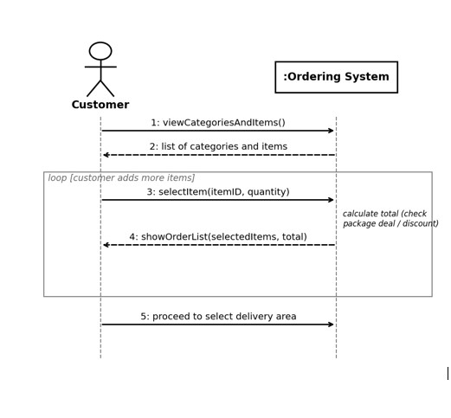

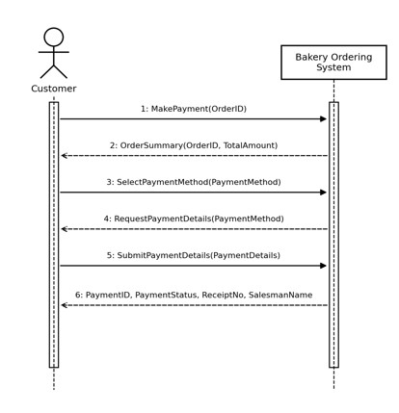

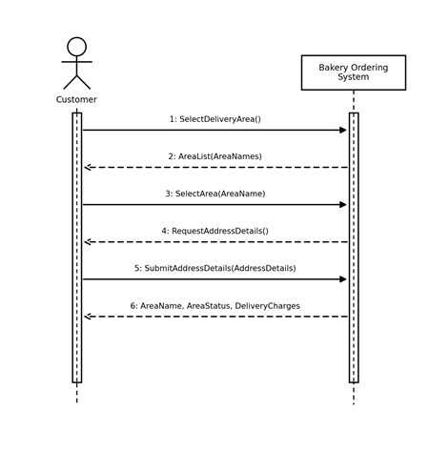

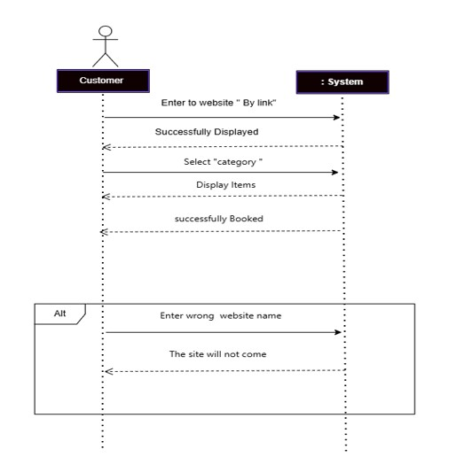

Domain Model
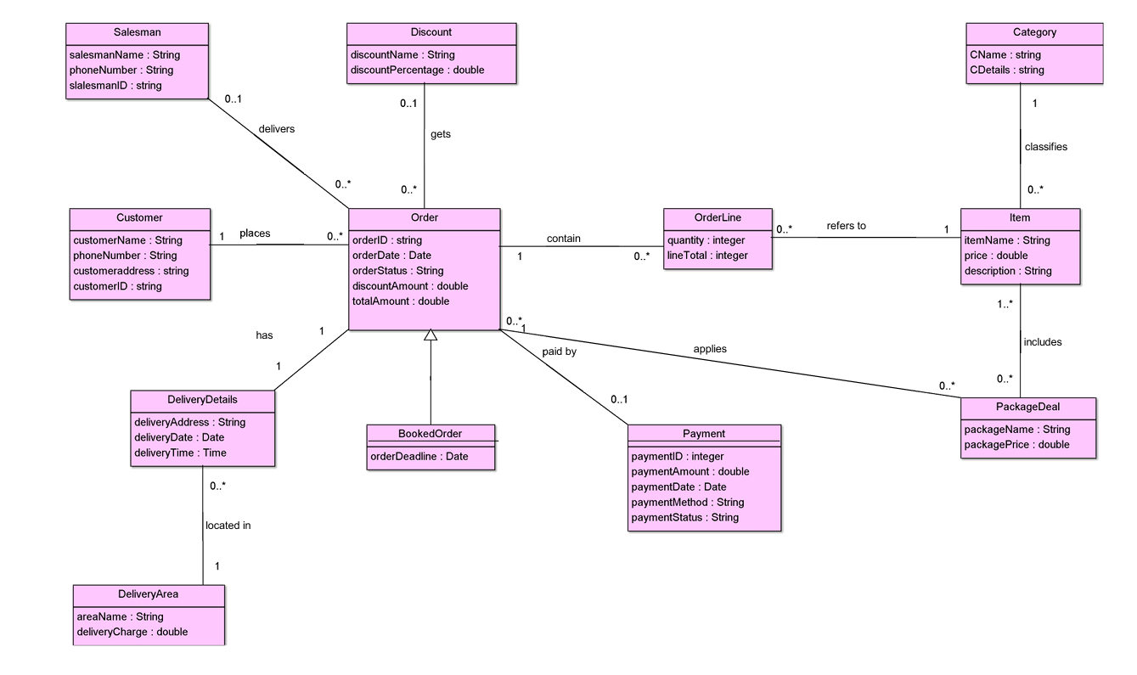

Use case

